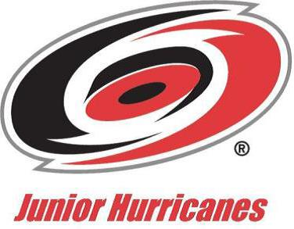
Carolina Junior Hurricanes

7/20/2022

Enter Teacher/Principal Name
Enter School Name
Enter School Address

Dear Mrs. Enter Last Name:

We are pleased to announce that one of your students, Enter Player’s Full Name, was selected as a member of one of our Carolina Junior Hurricanes ice hockey teams. The Carolina Junior Hurricanes is a draw exceptional players from all over the North Carolina. Enter Player’s First Name competed in rigorous tryouts last June to earn his spot on this USA Hockey Tier II team. The Tier II level teams play at a high competitive level and compete toward Regional and National Championships. These players are student-athletes dedicated to developing their skills to the highest level possible in relation to their sport.

During the hockey season, September through April, competition structure may require our players to travel on Thursday afternoons or Friday mornings. Our current schedule has our teams traveling once or twice a month. In some cases games start on Friday morning and go through the weekend.
Enter Player’s First Name will be traveling to locations such as List the cities to which you will be traveling.

On behalf of the Carolina Junior Hurricanes, we are writing this letter to ask that school administration allow Enter Player’s First Name excused absences on the affected days and be given the opportunity to do assignments in advance or make up any missed assignments, class work or tests. It is the Carolina Junior Hurricanes’ mission to make sure that all student-athletes maintain exceptional grades while being part of the program. It is our goal and hope that Carolina Junior Hurricanes are true scholar athletes.

We hope all will agree that an opportunity to play on such a team, in itself, is an invaluable educational and life-enriching experience. If you would like more information about the Carolina Junior Hurricanes program, please see our website at: www.juniorhurricanes.org. You also can read about USA Hockey at www.usahockey.com. Please feel free to contact me if you have any questions or concerns regarding Enter Player’s First Name hockey.

Sincerely,

Stephen Henley

Stephen Henley
Executive Director
Carolina Junior Hurricanes/
Executivedirector@juniorhurricanes.org

